**Configuration – Samitee & Member (Member)**  
Bug Report

Cycle 1

Afrida Rahman

Last Executed: 25/05/2024

**Member:**

* Individual
  + Registration
  + Authorization
  + Information Change
* NID Verification
* Close
* Dead Member Identification

**Individual (Registration)**

1. Mismatch between SRS and the System in member registration in Member module. In SRS “Member Type” will be in dropdown list type.

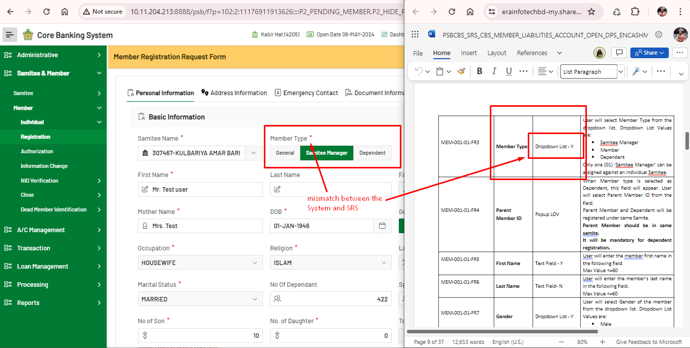

1. mismatch between SRS and System in gender field in Member registration form.

In SRS “Gender” will be in the dropdown list type.

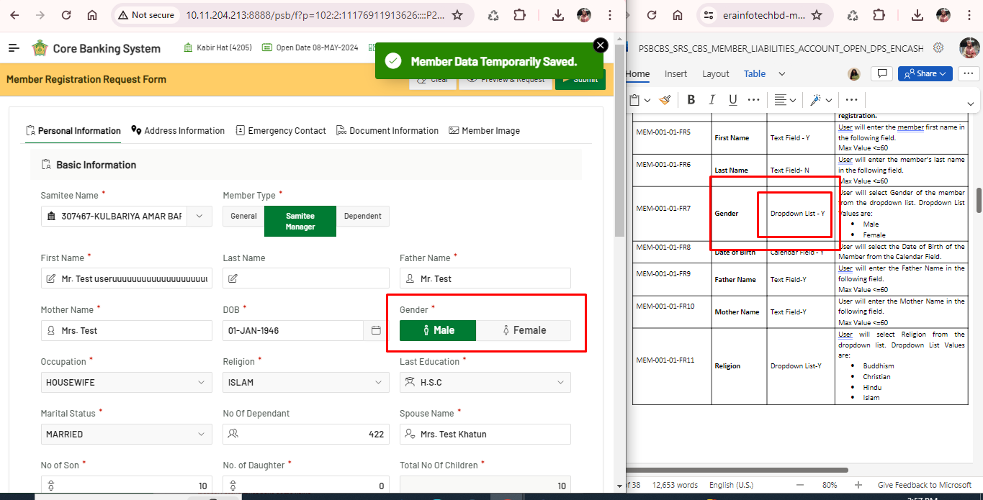

1. Spelling mistake in “Religion”, It should be “BUDDHISM”, instead of “BUDDHISHM”.

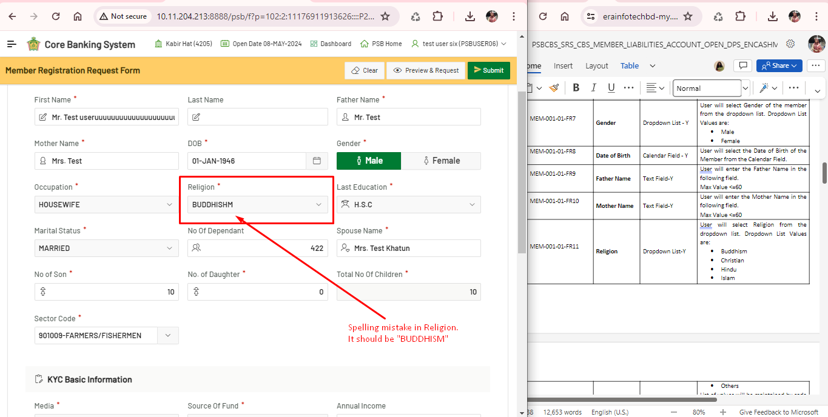

1. Mismatch between SRS and the System in “Marital status” in member registration.
   * In SRS written “DIVORCED”, where in System it is written “DIVORCEE”.
   * “WIDOWER” is not given in SRS.

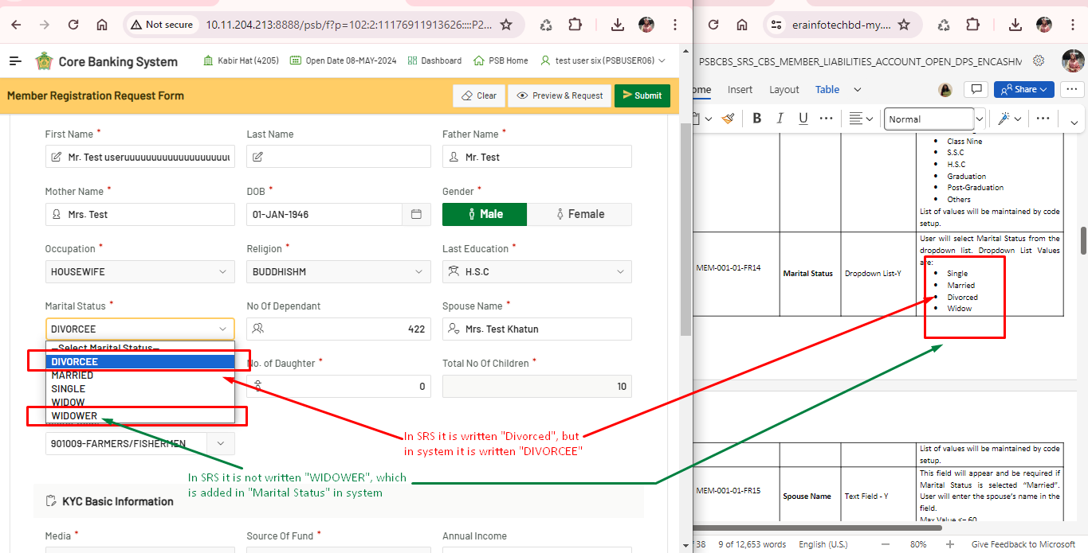

1. Address error in Registration Member in Samitee and Member module. It shows error as Address is already added, but Permanent address is not added yet.

